SIMATS ENGINEERING (SAVEETHA SCHOOL OF ENGINEERING)
Department of Computer Science and Engineering
ASSESSMENT TOOL 2 – ASSIGNMENT
Course Code: | CSA0901 | Course Title: | Programming in Java
CO Assessed: | CO2 – Precision (BL3,BL4) | Assessment: | ASSESSMENT TOOL 2 - ASSIGNMENT
Weightage: |  | Total Marks: | 100
CO1 Statement: | Implement Collection Framework interfaces such as List, ArrayList, Set, Map, HashTable, and HashMap using iterators and generics to store, retrieve, and process groups of objects in web applications
Student Name: | PRIYA MITHRA S | Reg. No.: | 1924260060
Section / Batch: | SLOT B | Date: | 03/08/2026

Code of Conduct
I __PRIYA_MITHRA_S__ (Name / Reg No) certify that this submission is my original work and that I have adhered to the guidelines specified for this assessment. I understand that any violation of academic integrity rules will result in disciplinary action.

Signature of the Student: _PRIYAMITHRA S____

Instructions
- This test contains 1 questions Total: 100 Marks.
- No negative marking. Un answered questions carry zero marks.
- No calculators or electronic devices permitted.
- Duration: 30 minutes.

Rubrics for Calculation
Criteria | Weightage | Level 4 – Exemplary | Level 3 – Proficient | Level 2 – Developing | Level 1 – Beginning
Problem Understanding & Context Analysis | 20% | Identifies all inputs, outputs, constraints accurately | Minor missing elements | Partial understanding | Incorrect interpretation
Application of Concepts | 30% | Complete, correct, and logically sound solution | Minor logical gaps | Partially correct logic | Incorrect approach
Analytical & Decision-Making Skills | 20% | Efficient and appropriate use of loops, conditions, functions/modules | Minor inefficiencies | Limited or basic usage | Incorrect or missing constructs
Solution Design & Approach | 10% | Well-structured, clear, consistent  format, easy to follow | Mostly clear with minor issues | Difficult to follow in parts | Poorly structured and unclear
Clarity, Justification & Presentation | 20% | Handles all cases; optimized approach | Handles most cases;  reasonable efficiency | Handles basic cases only | Incomplete or inefficient

Assignment–1
Course: Programming in Java
Topics: Java String Handling, Java Collection Framework, Collection Interfaces, Collection Classes, Iterators, Generics and Collections
Instructions
- Each student will be assigned one distinct question.
- Implement the solution using Java.
- Use appropriate classes, objects, methods, exception handling, collections, iterators, and generics wherever applicable.
- Include sample input, output, and screenshots of the program execution.
- Submit the source code and a brief explanation of the logic used.

Mark Distribution
Criteria | Marks
Problem Understanding and Algorithm Design | 10
Program Logic and Correctness | 20
Appropriate Use of Java Concepts (String Handling/Collections/Iterator/Generics) | 30
Output Validation and Test Cases | 20
Code Readability, Documentation, and Coding Standards | 20
Total Marks | 100

Qno:26 Generic Box Class Implement a Generic Box<T> class to store and retrieve different types of objects.
Aim
To develop a Java application using Generics by implementing a generic Box<T> class that can store and retrieve different types of objects such as Integer, String, and Double.
Algorithm
- Define a generic class Box<T>.
- Declare a private variable of type T to store the object.
- Create a set() method to store an object in the box.
- Create a get() method to retrieve the object from the box.
- Create objects of Box using different generic types.
- Store Integer, String, and Double values.
- Retrieve and display the stored values.
- Demonstrate that the same generic class can work with different data types.
PROGRAM LOGIC:
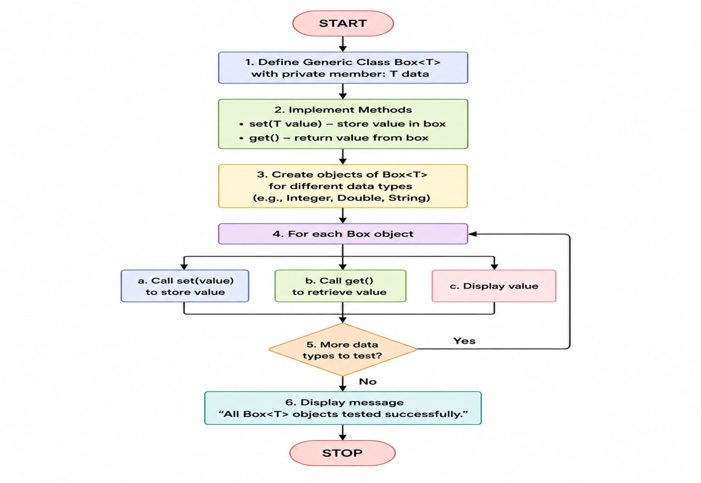

JAVA PROGRAM:
class Box<T> {
private T value;
public void set(T value) {
this.value = value;
}
public T get() {
return value;
}
public static void main(String[] args) {
Box<Integer> intBox = new Box<>();
intBox.set(100);
Box<String> stringBox = new Box<>();
stringBox.set("Hello Java");
Box<Double> doubleBox = new Box<>();
doubleBox.set(25.75);
System.out.println("Generic Box Values");
System.out.println("---------------------------");
System.out.println("Integer Value : " + intBox.get());
System.out.println("String Value : " + stringBox.get());
System.out.println("Double Value : " + doubleBox.get());
}
}

SAMPLE OUTPUT:
Generic Box Values
---------------------------
Integer Value : 100
String Value : Hello Java
Double Value : 25.75

GENERIC CLASS METHODS USED
Method | Purpose
set(T value) | Stores an object of type T in the box.
get() | Retrieves the object stored in the box.
Box<T> | Defines a generic class that can work with different data types.

GENERICS USED
Generic | Type | Purpose
Box<Integer> | Integer | Stores integer values.
Box<String> | String | Stores string values.
Box<Double> | Double | Stores decimal values.
T | Type Parameter | Allows the class to work with different object types.

RESULT
The program successfully demonstrates the use of Java Generics by implementing a Box<T> class. The same generic class is used to store and retrieve Integer, String, and Double objects, providing type safety, code reusability, and flexibility.

